Setting up Multi-Factor Authentication (MFA) for your school Microsoft account

MFA is required when accessing your school email, OneDrive, SharePoint and Teams from home.

What You Will Need
You will need your mobile phone and the Microsoft Authenticator app, which can be downloaded from the App Store or Google Play.

Please Note:
There are several ways to set up MFA.
This method is the quickest and easiest method.
The recommended security method is to use the Authenticator App for MFA rather than sending codes via a Text message or phone call.

Setting up your MFA for the first time (when on-site at school)
- On your mobile phone, download the Microsoft Authenticator app from the App Store or Google Play. Then open the app, ready for later.
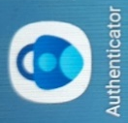
- On your computer, open a web browser and go to: https://myapps.microsoft.com
- You should be signed in automatically. If not, sign in using your school email address and password
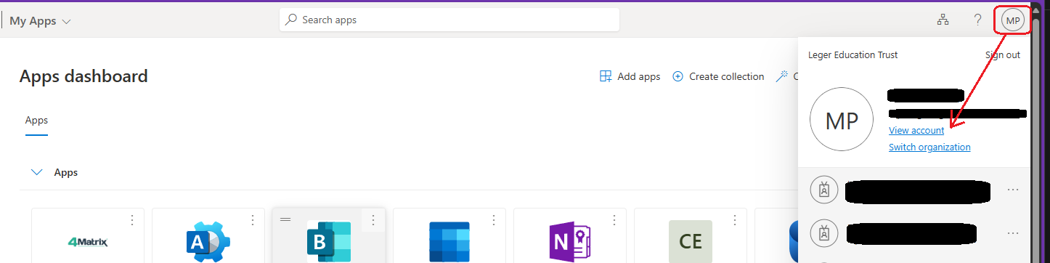
- Once signed in, click on your initials in the top right-hand corner of the page, then click on “View Account”
- On the left-hand side menu, select “Security info”
- Click “+ Add sign-in method” select “Microsoft Authenticator”

- It will not prompt you to get the Microsoft Authenticator app, hopefully you’ve already installed it.
Click on Next
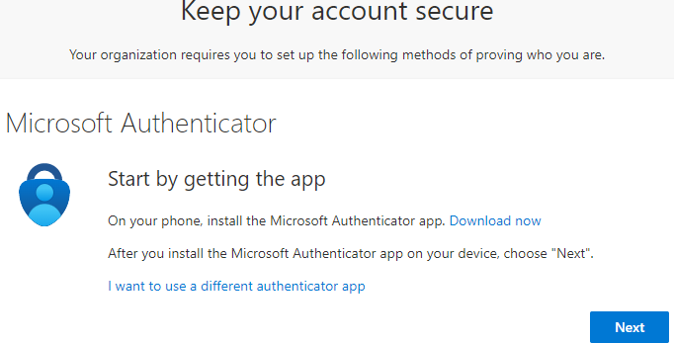
- Click on Next again
- It will now present you with a QR Code.
- Now go to your mobile phone, open up the Microsoft Authenticator app.
- Select “Add an account”
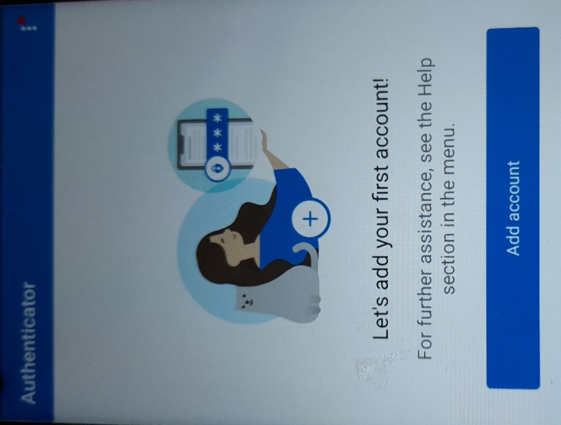
- Select “Work or school account”
- Select “Scan a QR Code”, if the phone prompts to allow access to the camera – select allow.
- Scan the code on the computer screen.
Note that the QR code is only valid for a few minutes. If it errors, then click on “Back” on the computer screen and then “Next” to generate a new QR code.
- Now click on “Next” on the computer screen
- It should now send a prompt on your phone to verify that MFA is set up.
It should prompt to verify that it is you using the phone e.g. Face ID or finger scan if you’ve set that up.
- It should now say on the computer screen that verification is successful.

Setting up your MFA for the first time (when at home)
This is the same process as above, except when you go to
https://myapps.microsoft.com on your personal computer
and sign-in, it will prompt you to complete setting up your account and create an authentication method.
Select the “Microsoft Authenticator” app when prompted. Then the rest is the same as above

Setting up your MFA on a new phone

If you’ve got a new phone and need to set up MFA on it, follow the process below.
The quickest way to do this is to have your old phone with you.
If you don’t have your old phone anymore, then you’ll need to get in touch with IT to reset your MFA settings, and then follow the instructions for setting up MFA for the first time.

Follow the above steps 1-5
Opening the “Security Info” usually prompts for verification on your old phone
Now you’ll see all your authentication methods – don’t remove any at this point
Now follow step 6 until the end.

When you’re back at the “Security Info” page, you should see your new phone added as “Sign-in Method”
If so, now you can delete your old phone as a sign-in method, and you can remove your school account from the Microsoft Authenticator app on your old mobile device.

All new MFA prompts will now go to your new phone.

